Ex. No. : 01B Date: 02-02-2026
Register No.: 231701023 Name: S.V.Jashwanth

Check In & Check Out
Aim
Develop an application for Tech Lounge Check in / Check out App. to count number of students inside the block.
Procedure:
- Open Android Studio and create a new project using Empty Activity.

- Select Kotlin as the programming language.

- Design the layout using a TextView to display the count and two Buttons for Check In and Check Out.

- Open the MainActivity.kt file and connect the TextView and Buttons using findViewById.

- Write logic so that when Check In is pressed, the student count increases.

- Write logic so that when Check Out is pressed, the student count decreases.

- Run the application and verify that the count updates correctly on each button press.

AndroidManifest.xml

<?xml version="1.0" encoding="utf-8"?>
<manifest xmlns:android="http://schemas.android.com/apk/res/android"
xmlns:tools="http://schemas.android.com/tools">
<application
android:allowBackup="true"
android:dataExtractionRules="@xml/data_extraction_rules"
android:fullBackupContent="@xml/backup_rules"
android:icon="@mipmap/ic_launcher"
android:label="@string/app_name"
android:roundIcon="@mipmap/ic_launcher_round"
android:supportsRtl="true"
android:theme="@style/Theme.CheckInCheckOut">
<activity
android:name=".MainActivity"
android:exported="true">
<intent-filter>
<action android:name="android.intent.action.MAIN" />
<category android:name="android.intent.category.LAUNCHER" />
</intent-filter>
</activity>
</application>
</manifest>

Activity_main.xml

<?xml version="1.0" encoding="utf-8"?>
<LinearLayout xmlns:android="http://schemas.android.com/apk/res/android"
xmlns:app="http://schemas.android.com/apk/res-auto"
xmlns:tools="http://schemas.android.com/tools"
android:id="@+id/main"
android:layout_width="match_parent"
android:layout_height="match_parent"
android:orientation="vertical"
tools:context=".MainActivity" >
<TextView
android:id="@+id/textView2"
android:layout_width="match_parent"
android:layout_height="wrap_content"
android:layout_marginTop="20dp"
android:fontFamily="@font/alegreya_semibold"
android:gravity="center"
android:text="Check In and Check Out"
android:textColor="#9C27B0"
android:textSize="34sp" />
<TextView
android:id="@+id/textView"
android:layout_width="match_parent"
android:layout_height="wrap_content"
android:layout_marginTop="20dp"
android:fontFamily="@font/arbutus_slab"
android:gravity="center"
android:text="0"
android:textColor="#663CDB"
android:textSize="48sp" />
<Button
android:id="@+id/txtCheckIn"
android:layout_width="match_parent"
android:layout_height="70dp"
android:layout_marginLeft="20dp"
android:layout_marginTop="40dp"
android:layout_marginRight="20dp"
android:fontFamily="@font/alegreya_semibold"
android:text="Check In"
android:textSize="24sp" />
<Button
android:id="@+id/txtCheckOut"
android:layout_width="match_parent"
android:layout_height="70dp"
android:layout_marginLeft="20dp"
android:layout_marginTop="40dp"
android:layout_marginRight="20dp"
android:fontFamily="@font/alegreya_semibold"
android:text="Check Out"
android:textSize="24sp" />
</LinearLayout>

MainActivity.kt
package com.example.checkincheckout
import android.os.Bundle
import android.widget.Button
import android.widget.TextView
import androidx.activity.enableEdgeToEdge
import androidx.appcompat.app.AppCompatActivity
import androidx.core.view.ViewCompat
import androidx.core.view.WindowInsetsCompat
class MainActivity : AppCompatActivity() {
private var count=0
override fun onCreate(savedInstanceState: Bundle?) {
super.onCreate(savedInstanceState)
enableEdgeToEdge()
setContentView(R.layout.activity_main)
val textView=findViewById<TextView>(R.id.textView)
val btnCheckIn=findViewById<Button>(R.id.txtCheckIn)
val btnCheckOut=findViewById<Button>(R.id.txtCheckOut)
btnCheckIn.setOnClickListener {
count++
textView.text=count.toString()
}
btnCheckOut.setOnClickListener {
if(count>0){
count--
textView.text=count.toString()
}
}
ViewCompat.setOnApplyWindowInsetsListener(findViewById(R.id.main)) { v, insets ->
val systemBars = insets.getInsets(WindowInsetsCompat.Type.systemBars())
v.setPadding(systemBars.left, systemBars.top, systemBars.right, systemBars.bottom)
insets
}
}
}

Output

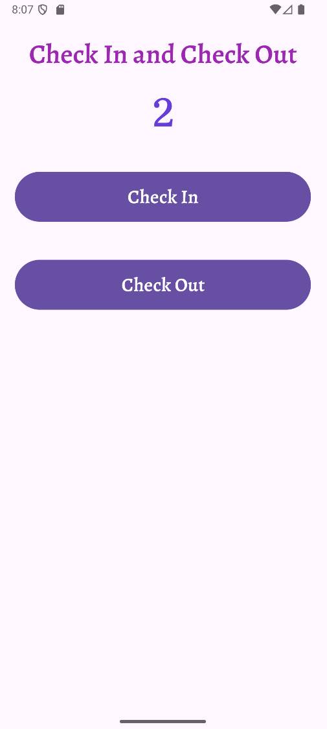

Result:
The application was successfully developed.
It counts the number of students inside the Tech Lounge by increasing the count on check-in and decreasing the count on check-out.

